

rEPORT FILE

CSE 326

|  |
| --- |
| Name:- Farhan Alam  Registration No.:- 12111501  Roll No.:-RK21YKB76 |

Introduction

In this file I have worked on the topic about Covid Information : Coronaviruses are a large family of viruses that are known to cause illness ranging from the common cold to more severe diseases such as Middle East Respiratory Syndrome (MERS) and Severe Acute Respiratory Syndrome (SARS). A novel coronavirus (COVID-19) was identified in 2019 in Wuhan, China.

I have made 5 webpages which include :

Home page

Awareness

Gallery

Log In

Contact Us

Home Page

# In home page I have first created it’s header and

**After that there is a navigation bar which links with galary and login page after that there is main heading.**

**After main heading there is detail information about the covid data with pictures at last there is footer which takes you to facebook , Instagram and linked in page to contact me.**

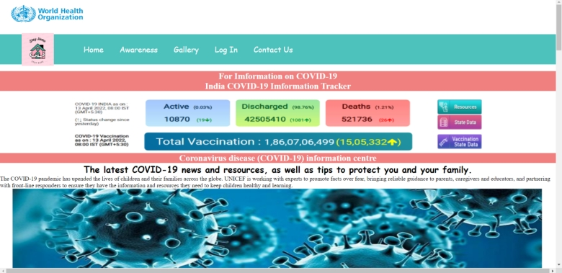

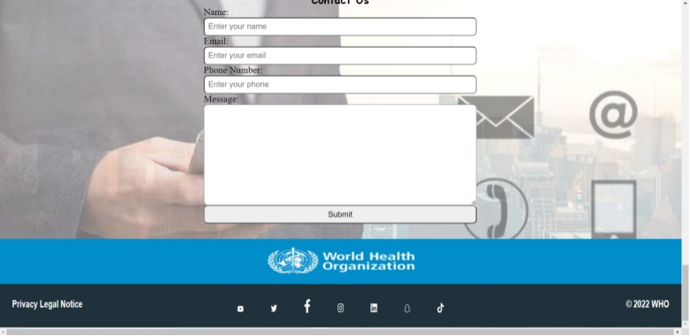

Awareness

After header images, there is some covid images, how to aware yourself to covid-19.

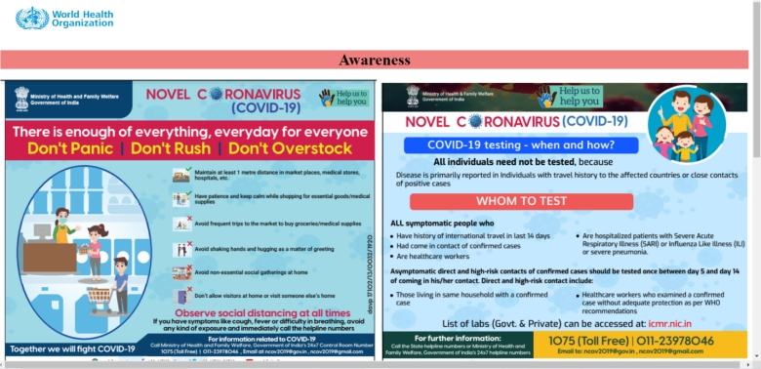

Login Page

In the middle of the page there is login box to login the user.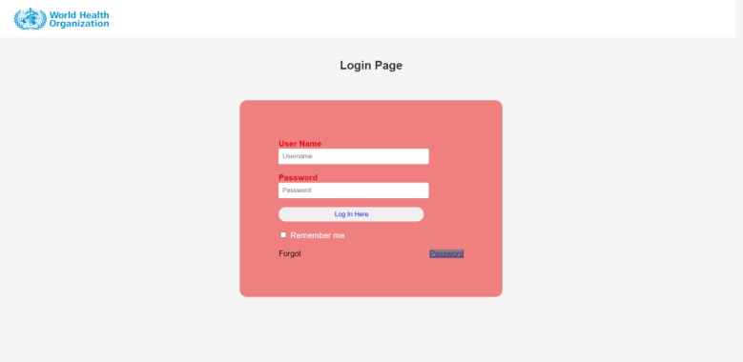

Gallary

After header images, there is some covid images, how to precautions yourself to covid-19.

